Learning resources
Introduction to Learning Resources (LRs) for teacher-educators



National Commission for Colleges of Education & Teacher Development Programme (NCCE & TDP)

Copyright
© National Commission for Colleges of Education & Teacher Development Programme (NCCE & TDP), 2015



This work is licensed under a
Creative Commons Attribution 4.0 License

Citation:
NCCE & TDP. 2015. Introduction to Leaning Resources (LR) for Teacher-educators. A module of the NCCE-TDP continuing professional development programme for teacher-educators. Abuja: National Commission for Colleges of Education and Teacher Development Programme (NCCE & TDP).

Acknowledgements
This module was developed by
Dr Umar Francis Audu francisaudu1963@yahoo.com Federal College of Education, Katsina.
Muhammad Dikko Ali {Ph.D} dikkojunior@gmail.com Federal College of Education, Katsina.
Dr Aliyu Umar Mohammed wooddust.comp@yahoo.co.uk Federal College of Education, Katsina.
Lawal Ibrahim lawalibrahim739@yahoo.com Federal College of Education, Katsina.
Dr Fatima Binta Suleiman fatimabintasuleiman@yahoo.com Federal College of Education, Katsina.
Aisha Dauda Daura aishaddr@yahoo.com Federal College of Education, Katsina.
In consultation with:
- The National Commission for Colleges of Education (NCCE), Abuja, Nigeria.
- The Teacher Development Programme (TDP, Abuja, Nigeria).
- The South African Institute for Distance Education (Saide)
The material uses the instructaional design template developed by
- Commonwealth of Learning (COL) – the template and many other useful resources are freely available from www.col.org.

Contents

How the module fits into the programme 3
Overview of content of module 3
How the module is structured 5
Introduction to Learning Resources for the NCCE-TDP CPD Programme for Teacher-educators 6
Welcome 6
Module outcomes 7
1. Why use Learning Resources? 9
1.1 Unit outcomes 9
1.2 Using Learning Resources to implement the curriculum 9
1.3 Using common resources to deepen learning 11
1.4 Using educational media to consolidate conceptual learning 15
1.5 What has this taught us about a 'Resource-Based' basic education? 16
1.6 Summary 17
1.7 Self-assessment 18
1.8 Selected references 18
2. Classification of Learning Resources 19
2.1 Unit outcomes 20
2.2 Community Resources (CRs) 23
2.3 Open Educational Resources 24
2.4 Types of learning resources 26
2.5 Summary 32
2. 6. Self-assessment 33
2.7 Selected references 35
3. 2D Learning Resources 36
3.1 Unit outcomes 36
3.2 Common types of 2D materials 37
3.3 Summary 44
3.4 Self-assessment 46
3.5 Selected references 46
4. 3D Learning Resources 47
4.1 Outcomes 47
4.2 Understanding 3D shapes 47
4.3 Different 3D shapes 52
4.4. Summary 53
4.5 Self-assessment 53
4.6 Selected references 54
5. Selection of Learning Resources 55
5.1 Outcomes 55
5.2 Principles guiding the selection of Learning Resources 56
5.3 Criteria for selecting DVDs, videos and audios (audio visuals) 60
1. “ How to Select High-Quality Materials by Massachusetts ESE, available at 62
5.4 Criteria for selecting LR on websites 63
5.5 Summary 64
5.6 Self-assessment 66
5.7 Selected references 68
Glossary 68

How the module fits into the programme

Overview of content of module
The NCCE curriculum reform calls for new ways of teaching that are more learner- and learning-centred. This requires that classrooms should become more activity- and resource-based. This module therefore explores the nature and potential of learning resources (LR) in support of more interactive classrooms.
This is a very ‘hands-on experience’ and practical module. Being on this course will allow teacher-educators to identify areas where the use of learning resources would be beneficial, explore current learning resources that are available, as well as design, develop, construct and examine the possible implementation of learning resources for the learning and teaching processes in Nigeria.
As you saw in the Teaching and Learning Methods module, there is an increased emphasis on teaching skills and the repercussions it holds for the manner in which we teach. There is a shift towards construction of knowledge with less emphasis on passive learning. Constructivism holds that learning is essentially active. Constructivists argue that by definition, a person who is truly passive is incapable of learning. In constructivist learning, each individual structures his or her own knowledge of the world into a unique pattern, connecting each new fact, experience or understanding in a subjective way that binds the individual into rational and meaningful relationships to the wider world (Wilson & Davis, 1994).
The teacher-educator will realize that he or she cannot teach effectively without using learning resources (LR). His/her teaching will now be more interesting thereby enabling him/her to be a more successful educator of student teachers. Teachers in turn gain greater student interest and improved reading and literacy skills among their students when they use LR. The teacher-educator, and in turn the classroom teacher, does less of the talking during the interactions and learners do more, giving them the opportunity to explore concepts more thoroughly.

By the end of this module you will be able to identify, design, construct and apply learning resources effectively during and after your lesson, through face-to-face contact and by distance learning. Thus, transforming you into a more effective teacher-educator.
To assist teacher-students to become resourceful in their learning, teacher-educators need be able to answer some questions:
- What are the sources of learning resources?
- How can we implement 'resource-based' and experiential learning in our classrooms?
- How can we turn non-educational resources into good learning resources?
- What are the relative educational strengths and weaknesses of different kinds of learning resources?
- What are the principles guiding our selection of learning resources?
- How can we design, construct, modify and adapt various learning resources in our classrooms?
- How can teacher-educators integrate learning resources into meaningful learning activities?
This module is divided into five units, each of which addresses the above questions, from a different perspective. Although the themes can be studied separately, they should be read together to provide comprehensive guidance in answering the above questions.
Unit 1: Application of Learning Resources
The authors of this module encourage teacher-educators to be more exploratory. They show how teacher-educators can use a much wider range of learning resources – particularly common resources (that is resources not designed primarily for educational purposes) – to enrich their teaching. We demonstrate how a range of 'new' and 'old' resources can be used both to engage learner interest and to develop higher-level conceptual understanding of the learning area. Through examples and case studies, the unit explores ways in which such media can be used to supplement teaching across the curriculum. The unit elucidates how an ordinary resource can be turned into an educational resource.
Unit 2: Classification of Learning Resources:
This unit identifies two basic formats used in classifying learning resources. Then through examples and case studies, it explores how community and OERs can be sorted out and used to supplement teaching across the curriculum in general and to help improve listening and understanding in particular. In this unit you are also expected to study, analyze and interpret the content of learning resources, and have insight into different components of learning resources and the channels or media through which learning can be enhanced, scaffolded and consolidated.
Unit 3: 2D Learning Resources:
This unit will guide you to explore different 2D learning resources within and outside the college environment. It begins by exploring the meaning of 2D learning resources and why 2D resources are central to teaching. It then discusses the strengths and limitations of 2D learning resources as a preparation for an exploration of the principles guiding the selection of appropriate 2D resources and their effective utilization in teaching and learning.

Unit 4: 3D Learning Resources:
In this unit, we explore the various dimensions of 3D learning resources and expose Teacher-educators to their characteristics and how to design, create, modify and adopt these resources to the benefit of teaching and learning. It will also expose the Teacher-educator to websites and how to access these materials for effective teaching and learning.
Unit 5: Selection of Learning Resources
Using community and OERs, the authors by way of examples and case studies, explore how Teacher-educators can develop necessary skills in selecting appropriate learning resources. The unit further guides the Teacher-educator to analyze various criteria for selecting LRs such as vocabulary and sentence structure and also to determine appropriate websites that can be used as sources of LRs or as LRs in their own right. It also shows how suitable CDs/DVDs could be identified as part of an appropriate teaching and learning environment.

How the module is structured
The module consists of the following:
- Welcome to the module
- Module outcomes.
- Content of the module, divided into units.
- A module summary.
- Self assessment.
- References.
There are five units:
- Application of Learning Resources (U. F. Audu)
- Classification of Learning Resources (M. D. Ali)
- 2D Learning Resources (F. B. Suleiman & A. D. Daura)
- 3D Learning Resources (L. Ibrahim)
- Selection of Learning Resources (A. M. Umar)

Introduction to Learning Resources for the NCCE-TDP CPD Programme for Teacher-educators

Welcome

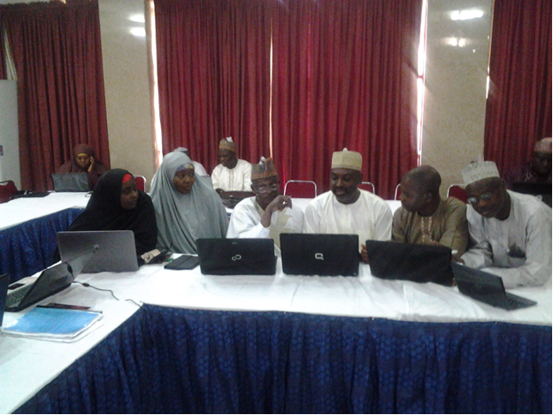
The picture above illustrates the kind of interaction we hope to foster in the CPD programme. Each teacher-educator enters the CPD programme with a wealth of prior knowledge and experience. We want to create spaces for the sharing of this accumulated wisdom in responding to the new challenges of changing times and curriculum reform. Before we begin to engage with the content of this module, have a look through the intended learning outcomes.

Module outcomes

Upon completion of the module you will be better able to:
  Outcomes | - Explain how common resources can be turned into learning resources.  - Explain the concept of Learning Resources.  - Outline the principles guiding the selection, design and utilisation of Learning Resources.  - Examine the strength and limitations of 2D and 3D Learning Resources.  - Integrate Learning Resources into the lesson plan.

Link to rest of programme

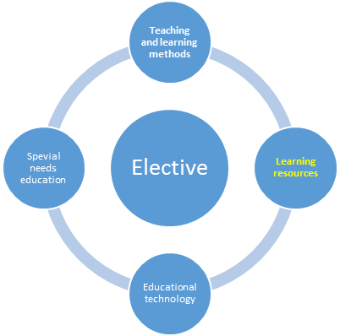

Figure 1: Relation of module to programme
As can be seen in Figure 1, this module is one of four inter-related core modules in the CPDC programme. The four core modules complement one another and should inform practice in an elective field of specialisation later in the programme.

Why use Learning Resources?

The authors of this module seek to encourage Teacher-educators to be more exploratory. They show how Teacher-educators can use a much wider range of learning resources – particularly common learning resources (learning resources not designed primarily for educational purposes) – to enrich their teaching. We demonstrate how a range of 'new' and 'old' resources can be used both to engage learner interest and to develop higher-level conceptual understanding of the learning area. Through examples and case studies, the unit explores ways in which such media can be used to supplement teaching across the curriculum. The unit elucidates how an ordinary resource can be turned into an educational resource.

1.1 Unit outcomes

Upon completion of the unit you will be able to:
Outcomes | • Explain how an ordinary resource can be turned into an educational resource.  • Plan and teach a resource-based lesson in your learning area that uses a range of media-based resources in achieving your desired educational outcomes.

1.2 Using Learning Resources to implement the curriculum

Using everyday resources to engage learner interest
A teacher-educator calls his students to the back of the College's compound and points to a waste dump. The class looks in amazement at the assortment of objects that were deposited at the back of the College by their neighbours. Umar, the teacher-educator, turns to the class and says:
‘These are found in most Nigerian cities. It speaks volume of our national development and laws guiding the land. What is your feeling about this dumping?’ Building on his students' responses, he continues, ‘Yes this dumping may be detrimental to the natural beauty of our college and when visible from roadways, is aesthetically unpleasant. We can turn this ugly situation into our advantage, however. How can we do that?’ he asked.
a

  Activity 1a | Purpose  This activity will help you to see the contribution of your immediate environment to teaching and learning.  Time  This activity should take about 20 minutes.  Activity 1  Take a close look at the dump and discuss with your colleagues what you think is happening here. What can you make out of it? Is it possible to sort out some objects from this dump that could be used for teaching and learning? Now:  - Write up an accurate description of what you think is going on here and how you can use this dump to your students' advantage.  - Why did Umar start his lesson like this? What was he trying to teach his students?  - Which objects in this dump can later be used in your own lesson? Sort them out.

Discussion

Discussion
What was this teacher trying to do?
Some of you may have said that Umar is wasting everyone's time. After all, he didn't explain the purpose of his lesson. You probably also found it very difficult to agree on the fact that we can turn the illegal dump into our advantage. This was his reply:
'First, I wanted my students to use their imaginations. I wanted them to paint a picture of this dumping in their heads. Second, I wanted them to think, to make use of an ugly situation to solve social problems. This is an important learning outcome, especially in the sciences and humanities. Third, I wanted to intrigue them. I wanted them to be practical in their response to issues like this, in our country. I also showed them the need for collaboration in solving life problems.
Though the effects of illegal dumping is an important lesson, Umar's teaching method is not only to introduce learners to the key scientific concept of “exploring your environment": he was also developing two other essential learning skills:
- The ability to observe. This means to analyse and sort out things and by doing so, to convert unuseful things to usefulness. This kind of skill will also be used in analysing poetry and literature, solving mathematics problems, understanding social inquiry, and so on.
- The ability to imagine. This is a skill that will also be used in a number of learning areas. Being able to 'brainstorm' as many answers as possible before narrowing these down to a final choice is an important benefit of learning that will assist the individual in solving human social problems.

You can see that these approaches are consistent with the more active learning advocated in the Teaching and Learning Methods module.

1.3 Using common resources to deepen learning
What did Umar do with the interest he had evoked? What concrete knowledge, skills or attitudes did he proceed to teach his students? Umar's next move was to ask his students to bring out the objects they had sorted out of the dump and group them according to different curricula at basic level. He presented to each group the demands of the new NCCE minimum standard for Early Childhood Care Education (ECCE), Primary Education, Adult and Non-formal Education and special needs. They were asked to look at the basic curriculum at their disposal and examine resources sorted from the dump. Which of those resources from the illegal dump can be used to promote teaching and learning in the basic classroom? Umar asked his students whether the dump itself can be used as a learning resource or source of learning resources. There was a lot of debate, but Umar insisted that students provide strong arguments as to the potential learning materials sorted out from the Illegal Dump (see examples below).



Figure 2: A Magazine



Fig 3a A Model (3D) Fig 3b A Model

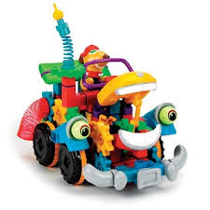

Fig 4 A combination of 2D & 3D shapes

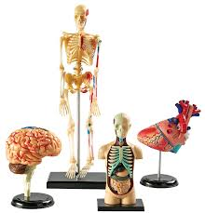

Fig 5a A 3D models
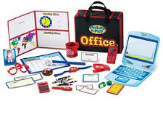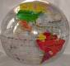

Fig 5b A model (combination of 2D & 3D) Fig 5c 3D (Globe)



Fig 6 A model (combination of 2D & 3D)
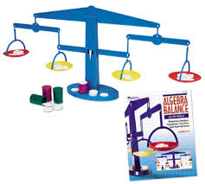

Fig 7 3D objects

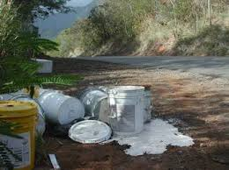

Fig 8 3D (Books) Fig 9 2D a picture

Why do they think the dump can serve as a source of learning resources?

While the class was still debating heatedly, Umar handed out to them the hand-out on the effects of illegal dumping (see hand-out A below). He told his class that people may be ignorant of the fact that they are destroying their neighbourhood with such illegal dump and ask them further to pinpoint the implications of illegal dumping to human life. He asked the class to relate their thought with the points in the hand-out and to debate whether they had the same opinions. When the double lesson ended, all the students were engrossed in reading the hand-out. Umar asked them to complete their reading at home and to write a full page explaining other implications of illegal dumping.

Hand-out A
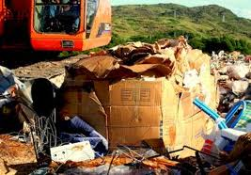
ENVIRONMENTAL, HEALTH, AND ECONOMIC EFFECTS OF ILLEGAL DUMPING
Illegal dumping can disrupt natural processes on land and in the water. Dumping can interfere with proper drainage of runoff. Areas are more susceptible to flooding when waste blocks ravines, creeks, culverts, and drainage basins. In rural areas, burning at dump sites can cause forest fires and severe erosion as fires burn away trees and undergrowth. The run-off from improper disposal of toxic substances such as motor oil or household cleansers can contaminate lakes, streams, and drinking water supplies.
Dumping also has a negative impact on plants and wildlife. Many birds and small animals die after ingesting or becoming entangled in debris. Fish and other aquatic species are killed when decomposing litter and food wastes in streams deplete oxygen supplies in the water. Refuse in a stream can also clog fish spawning areas.
Dumped appliances are not only an eyesore, but can also release toxic chemicals. Refrigerators and freezers may release chlorofluorocarbon (CFC) into the air, harming the earth’s protective ozone layer. Improperly discarded appliances built before 1979 may also leak polychlorinated biphenyls (PCBs) into the soil. According to the EPA, PCBs can cause cancer, reproductive failure and hormone imbalances in animals and humans.
Health. Appliances are a special danger for small children. Older refrigerators and freezers may look like fun forts or houses to kids, but they can easily become trapped inside. Other physical hazards to both children and adults include the risk of cuts and infections from protruding nails and sharp edges. There may also be less noticeable chemical hazards from toxic fluids or dust. Sites which include scrap tires are ideal breeding grounds for mosquitoes. The insects can breed 100 times faster than normal in the warm, stagnant water which collects inside the tires. Some of the mosquitoes can carry life- threatening diseases such as Dengue Fever, Yellow Fever, and Encephalitis. Other insects, rodents, and additional animals attracted to dumps may also pose health risks.
As mentioned previously, illegal dumps are also frequent sites for fire, either by spontaneous combustion or arson. The fires are extremely dangerous for those living in the area and especially for the fire fighters responsible for putting out the flames. Dumps can contain old aerosol cans or gas cans which can explode. Discarded chemicals from households and farms can also give off toxic smoke.
Economic. The presence of illegal dumps results in a decrease of neighborhood property values. The community as a whole also becomes unattractive to prospective commercial and residential developers. The loss of commercial development is especially damaging in poor counties where the unemployment rate is high and new employment opportunities are desperately needed. Also, without the tax revenues that accompany development, the funding available to establish and maintain effective illegal dumping prevention programs is limited.
The costs faced by local governments to continually clean up illegal dump sites are significant. Some areas have spent up to several million dollars each year for clean up, hauling, and disposal activities. The expense can then be passed to residents in the form of higher service fees or property taxes.

1.4 Using educational media to consolidate conceptual learning
Later we found that Umar hadn't just chosen any resources sorted out from the dump, he had chosen resources that had links with the content he needed to cover in the basic science and civic education curriculum. The lesson began with a couple of students sorting, grouping learning resources and reporting the implication of the dumping to human social behaviour and health. Umar allowed a few minutes for debate and discussion among students about the validity of the reasons given by other students. Then Umar began consolidating his lesson. He handed students a worksheet which asked them to examine the effects of illegal dumping as contained in the hand-out sorted from the dump.

1.5 What has this taught us about a 'Resource-Based' basic education?
We thought Umar's programme for his lessons was interesting in a number of ways. It demonstrated some of the best features of constructivist outcomes-based education, while not lapsing into the aimless and non-educational activities that sometimes characterise our teaching. We also thought Umar demonstrated how a range of 'new' and 'old' resources can be used both to engage learner interest and to develop higher-level conceptual understanding of the topic.

Here are some points that we would use to 'check' the quality of our own 'Resource- Based' teaching in future.

Good Resource-Based teaching
- It should engage learner interest: The lesson begins with a problem. This problem engages learner interest and gets learners thinking and talking.
- It should link learner experience with new and unfamiliar educational concepts: The activities draw on learner experience through exploration and observation which encouraged active learning: Umar uses a wide range of resources with good questions. This encourages active learning by learners rather than lecturing to passive learners. Umar seldom lectures, instead he observes and intervenes at critical learning moments. Students remain active throughout.
- It should develop in-depth skills and knowledge within an integrated learning area: Umar developed key scientific concepts and processes – he focused on enabling his students to do basic science – but also linked this to the broader understanding of society. He did this by taking the students to the site of illegal dumping before presenting the lesson content to them. This covered both Science and Humanity learning, and by means of a worksheet that had questions relating to all aspects of learning.
- It should use different resources to develop increasingly higher levels of learning: Umar elicits learner interest and gets them thinking by taking them out of the class to the site of the dump and asking them to sort out interesting objects. He then introduces short, environmental-flavoured articles from the common media (the Time magazine) and some new questions. Later Umar refers learners to longer bits of reading from educational media (such as textbooks and encyclopaedias) to consolidate their learning and to develop more sophisticated reading and writing skills.
- It should develop in-depth skills and knowledge within an integrated learning area: Umar developed key scientific concepts and processes – he focused on enabling his learners to do science – but also linked this to the broader understanding of the society. He did this by choosing issues on environment covered in the Science and Humanity learning areas, and by means of a worksheet that had questions relating to aspects other than science
- It should develop other critical outcomes across the curriculum: Umar created learner activities that developed both specific subject/ learning area skills and knowledge and generic skills and understanding, such as reading, thinking, writing, and debating.

1.6 Summary
- Many things can become learning resources: anything from our surrounding: the only limit is our imagination and our resourcefulness.
- We should use a wider variety of resources to activate learner interest, and to deepen their knowledge of abstract and difficult concepts. But we must realize that resources only become educational through the thoughtful intervention of a teacher.
- Planning learning processes is a very important skill in a resource-based basic curriculum. In particular, this must focus on leading a learner from the interest activated by an initial resource through to deeper conceptual understanding.
- Popular media resources are particularly good at:
- activating learners' experience and contextualizing school learning;
- providing learners with vicarious experiences they could never otherwise have: travelling back in time, visiting exotic worlds, listening to famous figures talk;
- evoking learners' imaginations;
- improving learners' ability to use language: reading, listening, second- guessing, modelling talk;
- improving learners' critical literacy;
- updating textbook content.

1.7 Self-assessment
  Assessment | We'd like you to do three linked activities at this point:  - Re-work the 'checklist' of criteria for good resource-based teaching that you have studied.  - Choose a key concept in the learning area you teach. Then develop a programme of activities using learning resources to teach this concept. Use your checklist to ensure that you include the important ideas that Umar and others have provided.  - Swap your learning programme with a fellow teacher. Assess each other's programmes and integrate any ideas you learn from your fellow teacher's programme into your own.  Now reflect on the following and revise anything you are not sure about. I am able to:
  # | Checklist | ☑
  1 | Explain how an ordinary resource can be turned into an educational resource. | ❑
  2 | Plan and teach a resource-based lesson in your learning area that uses a range of media-based resources in achieving your desired educational outcomes. | ❑
Now that we have thought a little about WHY to use Learning Resources (LR), it will be useful to explore the different categories of LR available. This is the focus of Unit 2.


1.8 Selected references
Abellera, R.C., Aquino, G.V., & Hidalgo, L.C. (1988). Principles of teaching and educational technology. Diliman, Quezon City: Kalayaan Press.

Corpuz, B.C. & Lucido, P.I. (2008). Educational technology 1. Q.C.: Lorimar Publishing, Inc.

Dale, E. (1954). Audio-visual methods in teaching. NY: Dryden Press.
You might also find the following freely available resource useful:
Using Media in Teaching at: http://www.oerafrica.org/african-teacher-education-oer-network-aten/using-media-teaching

2. Classification of Learning Resources
Teachers in today’s modern world are faced with many challenges ranging from over-populated classrooms, lack of facilities for effective teaching, seriously poor learning background on the part of learners, to lack of modern equipment.

The introduction of outcome-based or standards-based education in many countries has re-established the importance of learning as a process by emphasizing learner-centeredness and lifelong learning. The above emphasis calls for creativity, resourcefulness, inquisitiveness, colourfulness, manipulations and effective sound communication to make the learning interesting, focused, effective and efficient.

In order to meet the above challenges and to overcome the problems as well as to make learning more meaningful, the teacher-educator needs to be current, up to date and professionally qualified. Professional competency depends largely on the ability of the teacher-educator to acquire knowledge, skills, and attitudes to effectively fit into the modern classrooms and modern world.

Effective teaching in a 21st century context requires teacher-educators to be resourceful by effectively employing the use of various learning resources to facilitate, enhance, and motivate the learners. The purpose of learning and teaching resources is to provide a source of learning experiences for students. By building meaningful learning activities around learning resources, it becomes possible to facilitate greater interaction among students and teachers during the learning/ teaching process, as well as to help students to learn, broaden students’ learning experiences and to meet different learning needs. If used effectively, learning resources can help students to construct knowledge for themselves and develop effective learning strategies, generic skills, values and attitudes, thus laying a solid foundation for life-long learning.

The world has now become a global village where every piece of information can be shared within a twinkle of an eye. With the expansion in technology, students are exposed to a greater variety of learning resources (LR) than before. Learners need to be skilful in selecting and making good use of these resources and in this unit you are therefore expected to study, analyze and interpret the content of learning resources and the channels or media through which learning can be enhanced, scaffolded and consolidated. The question here is how can teacher-educators be exposed to effective use of learning resources? The unit also discusses learning resources from two broad areas: Community Resources and Open Educational Resources.

2.1 Unit outcomes
Outcomes
Upon completion of the unit, you will be better able to:
- Explain Community Resources (CR)
- Describe Open Educational Resources
- Identify and discuss types of Learning Resources

Educators as facilitators of learning  - As a resource- provider-facilitator and consultant to all classroom activities.  - You should realise that we are living in a rapidly changing world and it is necessary to draw examples from numerous sources and different perspectives to build knowledge. | Student-teachers as self-directed learners  - They should not only know the variety of learning resources but also how to make use of them.  - They should engage with learning outcomes and decide how best they can achieve them.

Activity 2a | Purpose  This activity will help you classify LRs.  Time needed for activity  This activity should take about 20 minutes  Question 1. From the above discussion and table what do you think could be classified as ‘learning resources’?  Question 1. From the above table think critically and add more on the possible uses of learning resources to both the teacher and the learners.  Consider the following statements and think critically to arrange the statements into two categories.  - Over dependence on teachers information/notes  - Teachers as “alpha and omega” of everything in the classroom  - Learners take charge of the learning environment  - Quality learning resources can offer student-teachers quality learning  - Students can take responsibility for their own learning  - Teacher-educators are trained to use learning resources and scaffold the right kind of support that will enable the students to make optimum use of such resources.
You are free to add more statements and categorize them into two groups (merits and demerits).

Activity 2b | Purpose  This activity will help you become familiar with different learning resources.  Time needed for activity  This activity should take about 10 minutes  Activity 2a: Study the following list of resources  - Open learning materials  - Resources pack  - Reading sets  - Lecture notes  - Manuals  - Seminar guide  - Laboratory guide  - Field work guide  - Project guide  - Staff use of students guide  - College code of conduct  - Work placement guide  - Logs  - Skills guide  - Skills profiles  - Text books  - Study guide  - Reading guide  - Course guide  - Real objects  - Specimens  - Regalia  - Models  - E-learning  - E-books  - Museum  - Gallery  - Zoo  - Market  - Institutions  - Organizations  - Television  - Library  - Monument etc.  Activity 2b: Look at the following question and provide solution  Question 1. Create a table and place the above items into two classes (Community Resources and Open Educational Resources)

2.2 Community Resources (CRs)
Community Resources are materials, objects, facilities, monuments, museums, zoos, organizations, institutions, environments etc. in short any materials and objects around us that offer people experiences to make their lives more meaningful and resourceful. The use of community resources includes a combination of people, places, financial resources, websites and materials. Teachers could also make use of public libraries, museums, educational parks and media (including newspapers, radio and television).

Think about the following questions and their possible answers
Question 1. Do you have any or know of any museum, zoo, or monument in your town?
Question 2. If your answer for 1 above is yes, visit one of these sites and take note of the various objects and materials which could enhamce your own teaching.

Study the following pictures, cartoons and images

Fig 1 A Market Fig 2 A Library

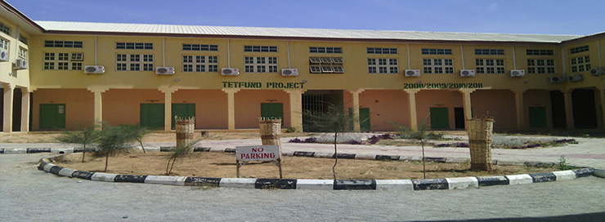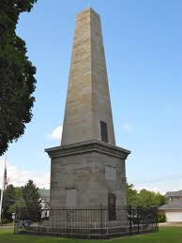
Fig 3 An Institution Fig 4 A Monument
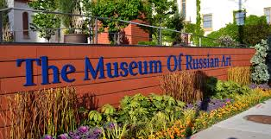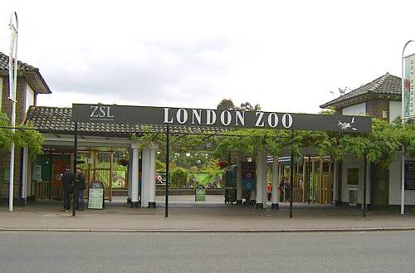

Fig 5 A Museum Fig 6 A Zoo

Fig 7 A Gallery

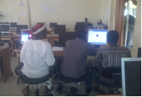
Fig 8 A Television Fig 9: An Organisastion

2.3 Open Educational Resources
Open Educational Resources (OER) are defined on the William and Flora Hewlett Foundation website as: "teaching, learning, and research resources that reside in the public domain or have been released under an intellectual property license that permits their free use and re-purposing by others. Open educational resources include full courses, course materials, modules, textbooks, streaming videos, tests, software, and any other tools, materials, or techniques used to support access to knowledge".

The Organization for Economic Co-operation and Development (OECD) defines OERs as: "digitized materials offered freely and openly for educators, students, and self-learners to use and reuse for teaching, learning, and research. OER includes learning content, software tools to develop, use, and distribute content, and implementation resources such as open licenses”.

Activity 2c | Purpose  To enable you learn more about classification of LRs.  Time needed  This activity can be done in 30 minutes.  - Compare the two definitions and analyze their key terms and come up with your own definition of open educational resources.  - View this YouTube video on turning a resource into an open educational resource and listen carefully to the video and comment on it  - Connect to the YouTube and search for the following videos  Use the following web address, to view the video on youtube, at  https://www.youtube.com/watch?v=CUVW5fhQP2k
Questions
- Comment on the video you have just viewed
- In your opinion what do you consider to be an OERs
- Comment fully on the concept of learning resources
- How could you use such a programme in your own area of specialization?

Use the following web address, to view the video on youtube at
https://www.youtube.com/watch?v=DXBhfH2TKd8
Questions
- Do you maintain your earlier comments on OER? If yes support with good examples if No suggest another view.
- Analyze the video you have just viewed and comment fully on what really is OER.

Use the following web address, to view the video
https://www.youtube.com/watch?v=Fp8ZLPvMUQI
Questions
- Discuss the video you have viewed and give your own assessment
- What really is the role of OER in teaching?
- Do you agree with the speaker? View the video again and write down the key characteristics of OER.
- Re-arrange the role of OER as presented in the video.
- Give additional roles of OER.

Use the following web address, to view the video
Baraniuk open source learning at youtube
https://www.youtube.com/watch?v=oz2Nqv5tKAk

Then answer the following questions;

Questions
- What are the key differences between David’s and Richard’s presentations?
- Comment fully on the two scenarios and come up with your own position.

Discussion
Discussion

Review the above videos, and refer your student teachers to search for OER that discuss the topics of your course. Prepare an activity for your students to help them access these resources.

From the above videos and scenarios we may say that OER should not be confused with Open Education. OER are freely accessible openly licensed documents and media that are useful for learning, teaching, assessing as well as for research purposes in both closed and open settings and in both contact and distance modes of provision. Permission is required before use or re-use of traditional all-rights reserved copyright resources and, in terms of the Berne convention, we have to assume this condition for any resource that has no copyright or licensing information. But OER can be utilized without asking for permission or paying royalties – the conditions for use or re-use are explicit in the licence. The essential purpose of OER is to promote and motivate the desire to contextualise and modify the knowledge and to enhance an open educational paradigm. The UNESCO (2002) Forum on Open Courseware defines OER as “teaching learning and research materials in any medium, digital, or otherwise that reside in the public domain or have been released under an open license that permits use, adaptation, and re-distribution by others with no or limited restrictions”.

Analyze the above definition and draw your own conclusion of the essence, meaning and potential role of OER. Refer to Educational Technology module units 1 and 2 for more explanation on OER, precisely pages 25 and 30.

2.4 Types of learning resources
Learning resources are not confined to textbooks and are available in many other forms such as reference books, workbooks, worksheets, audio-visual teaching aids, web-based learning materials, computer software packages, structured courseware delivered by electronic learning management systems, Internet and media, as well as libraries, learning communities and resources in the natural environment, etc. A wide variety of learning and teaching resources is readily available. Learning resources are materials that are readily available within our community. Almost any resource can be made into an ‘educational’ or ‘learning’ resource by designing an appropriate learning activity around that resource. For example, a discarded cool-drink can could become the basis of a discussion on pollution, recycling, packaging, properties of materials, analysing ingredients etc and/or could be repackaged as a classroom container e.g. for paint, pens etc and so become the basis of an arts and crafts lesson. Teacher-educators need to understand and utilize the potential of such resources for effective learning.
Examine these pictures, images and cartoons and think about how these resources could be used in the classroom

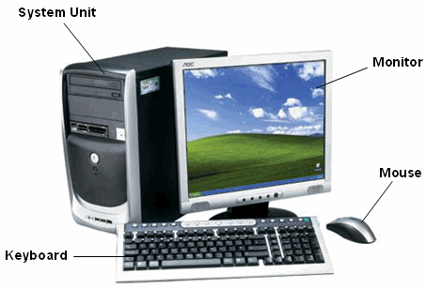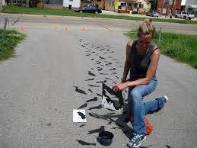
Fig 10 Computer System Fig 11 Field Work Guide

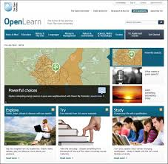
Fig 12 Open LearningMaterials Fig 13 Open Learning Materials
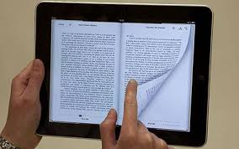
Fig 14 E-books Fig 15 E-learning
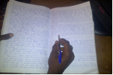

Fig 16 Laboratory Guide Fig 17 Lecture note
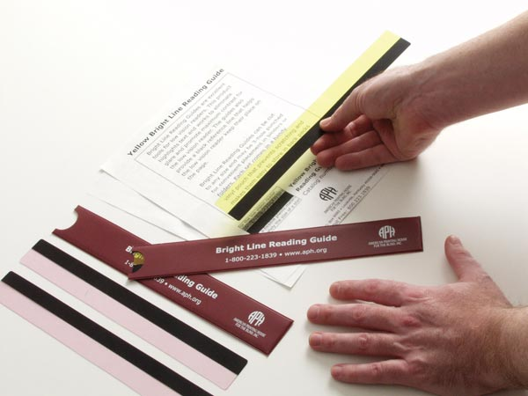

Fig 18 Project Guide Fig 19 Reading Set

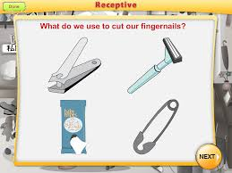

Fig 20 Real Object Fig 21 Seminar Guide
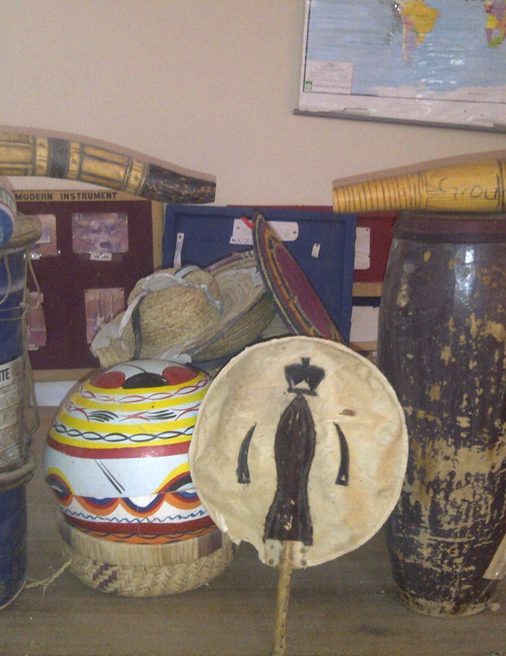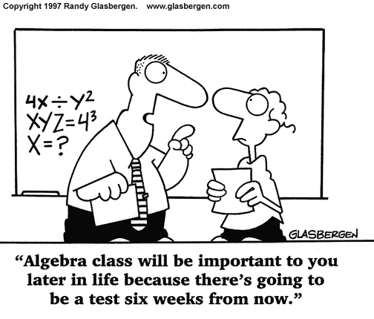
Fig 22 Regalia Fig 23 Study Guide
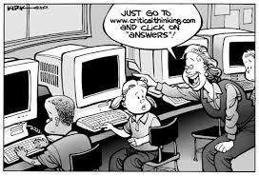

Fig 24 Skills Profile Fig 25 Skills Guide
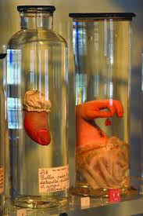
Fig 26 Specimens Fig 27 Work placement Guide

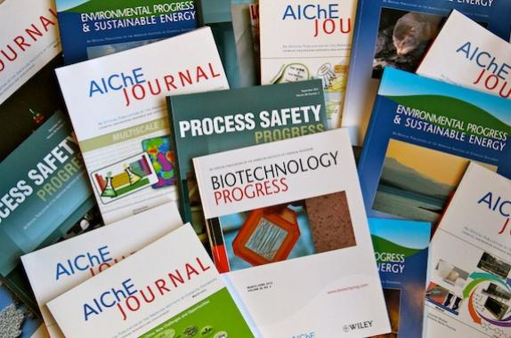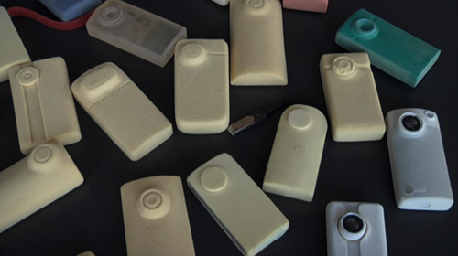
Fig 28 Logs Fig 29 Models

Fig 30 Skills guide
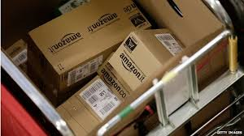
Fig 31 Learning pack
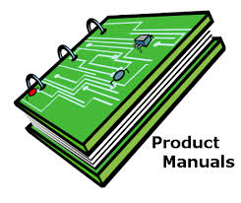
Fig 32 Staff and Students Guide

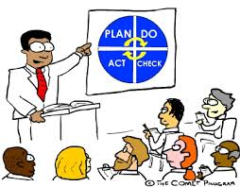
Fig 33 Staff and Students instructional Guide

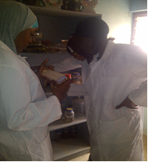
Fig 34 Course guide

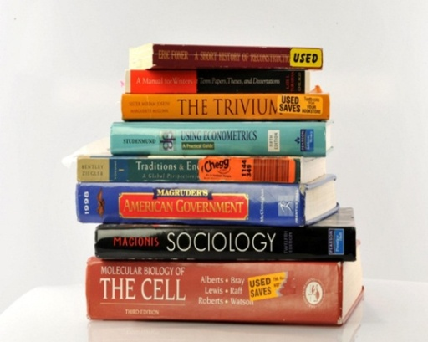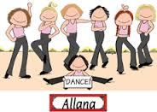
Fig 35 Text Books Fig 36 Dancing

 | Reflection  - Consider the above pictures, cartoons and images. Think critically about how you could group them into four types of learning resources.  - Comment on the above cartoons.  - What is your opinion on the pictures and images?
  
  Reflection

Think critically about the following Questions:

You are required to explain how varieties of learning resources are used
How do we as Teacher-educators create an effective learning environment?

What role do Audio-visual materials play in learning in our schools?
You need to know the importance of using all the senses in the human body in learning
Discussion

How should Teacher-educators use different learning resources to help student teachers do the same in their classrooms?

We experience a number of different types of learning resources. We also use them in our lessons at different times and different types of resources

- Open learning materials
- Resources pack Type 1.
- Reading sets resource contents.
- Lecture note

- Text books
- Study guide
- Reading guide Type 2. build on other
- Course guide resources.

- Manuals
- Laboratory guide
- Field work guide
- Project guides Type 3. support
- Seminar guide learning.
- Staff use of students guide
- Work placement guide

- Logs
- Skills guide Type 4.
- Skills profile support the learning process.

Considering the above diagram using your area of specialization comment on how you will use each kind of learning resources.

Resources that teach resource contents | Resources that build on other resources | Resources that support learning | Resources that support learning process
1.
2.
3.
4

Using your area of specialization give 4 examples in each column above.

2.5 Summary
From our discussions, we have seen various learning resources and in this unit we have grouped them into two classes i.e. Community Resources and Open Educational Resources. Here we are looking at Learning Resources from a holistic view. Ask.com define community resources as “anything that has the potential to improve the quality of life in a community, according to the Community Tool Box from the University of Kansas. Potential community resources include organizations, places, services, businesses and individuals”.
Traditional community resources start with organizations that focus on helping people, such as support groups and poverty outreach groups, but the definition of community resources is much broader. It includes public services, such as libraries and post offices; gathering places, such as community centers and churches; and businesses that serve the community by providing jobs and easy access to necessary products. Individuals who work to improve community life by helping others, cleaning up the community or organizing informal community activities are also community resources.
Study the above definition critically and analyse its functionality and its workability in classroom teaching. Using community resources, also consider the following sentences:
- Any potentiality that can improve the quality of life in the community
- Relate the community tool box from the University of Kansas and the learning in the classroom
- Analyze the broader definition of Community Resources
- Draw a conclusion of the concept Learning Resources and each classification, types and functions.

2. 6. Self-assessment

Self-assessment

Educators as facilitators of learning  - As a resource- provider-facilitator and consultant to all classroom activities.  2. You should realise that we are living in a rapidly changing world and it is necessary to draw examples from numerous sources and different perspectives to build knowledge. | Student-teachers as self-direct learners  - They should not only know the variety of learning resources but also how to make use of them.  - They should engage with learning outcomes and decide how best they can achieve them.

You are free to add more statements and categorize them into two groups (merits and demerits).

We have seen that there are many different kinds of resources that can be categorised in different ways. A categorisation that we find useful is between 2D and 3D shapes. These will be the focus of our attention in the next two units.
Tick the boxes to assess whether you have achieved the outcomes for this unit and for the module as a whole. If you cannot tick the boxes, you should go back and work through the relevant part in the unit again.
I am able to:
# | Checklist | ☑
1 | Explain Community Resources (CR) | ❑
2 | Describe Open Educational Resources | ❑
3 | Identify and discuss types of Learning Resources | ❑

2.7 Selected references
Key references and useful further reading include:
Burke, R. (1992). Teaching and Learning through broadcast and recorded media in University of London/TEC Course book for external diploma education. Course 3 unit 6 Adult Learning and Communication in Distance Learning

Butcher, N. (2011). A Basic Guide to Open Educational Resources (OER). Freely available under an open licence from Unseco at:
http://www.unesco.org/new/en/communication-and-information/resources/publications-and-communication-materials/publications/full-list/a-basic-guide-to-open-educational-resources-oer/

http://www.decs.sa.gov.au/schlstaff/ (2004). Choosing and Using Teaching and Learning Materials

Moll, I et.al (2002). Learners and Learning. Learning Guide and Reader. Cape Town: OUP/Saide. Freely available under an open licence from: www.oerafrica.org.za.

www.Ask.com, www.googlesearch.com

.

.

3. 2D Learning Resources
Two-dimensional (2D) learning resources consist only of length and width. They are paper-based, opaque materials that are commonly found in classrooms. These kind of instructional materials do not need any special equipment for their use. See drawings and sketches below. They are materials and objects that give support to the learner, to aid and facilitate learning. At this time, even in this technologically advanced generation, when you visit classrooms, the most common instructional material you will find are those that are two-dimensional.

3.1 Unit outcomes

Upon completion of the unit you will be better able to:
Outcomes | - Identify the different 2-D learning resources  - Describe the characteristics of 2-D learning resources  - Make 2-D learning resources  - Demonstrate proper use of 2-D learning resources  - Outline the importance of 2-D learning resources in the modern world.

Discussion
Look at the following power point presentations and compare with your answers.

Activity 3a | Purpose  This activity will help you to understand 2D LR.  Time needed  This activity should take about 15 minutes.  Make notes in your workbook on the following:  - From your teaching experience identify various 2D learning resources used in the classroom.  - Describe the characteristics of 2D LR listed above.  - Use cardboard paper to produce some examples of 2D LR.  - Then using the above products explain how they can be used.  - Outline the importance of 2-D learning resources

3.2 Common types of 2D materials
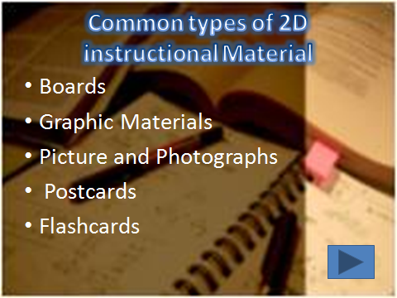
Fig 1 Types of 2D resources

3.2.1 Types of Boards
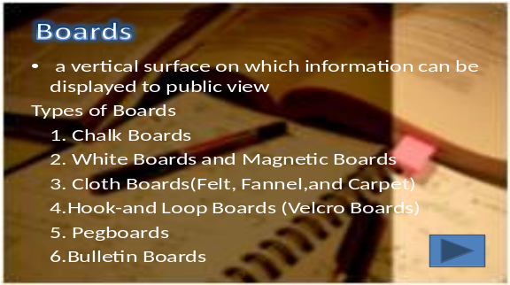
Fig 2 Types of borads
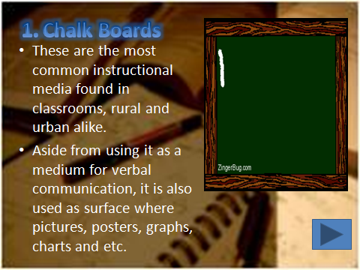
Fig 3 Chalk boards
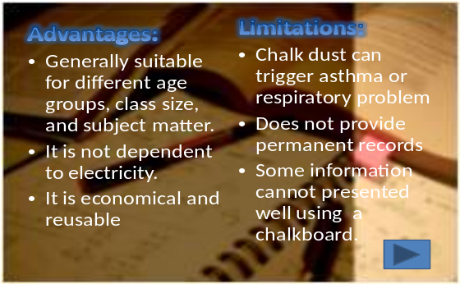
e
a
a
a

Fig 4 Chalk boards
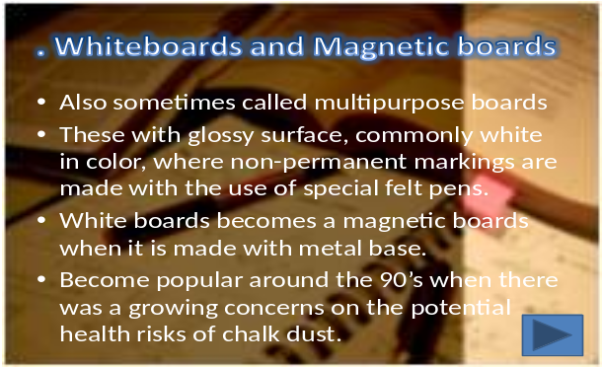

Fig 5 White and Magnetic boards
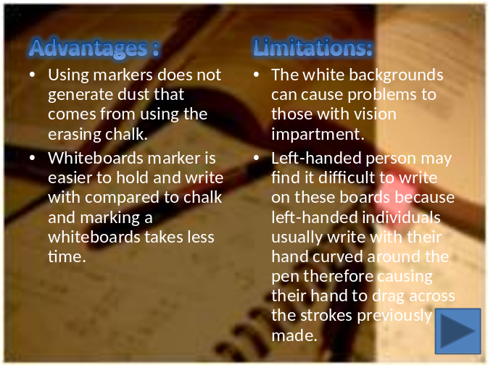
Fig 6 Advantages and limitations of magnetic boards

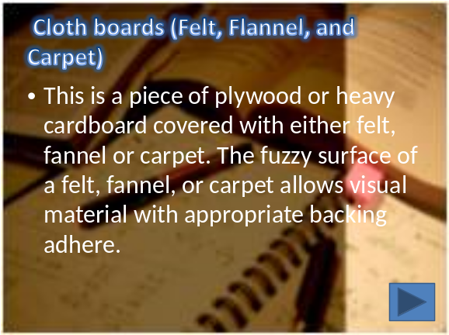
Fig 7 Cloth boards
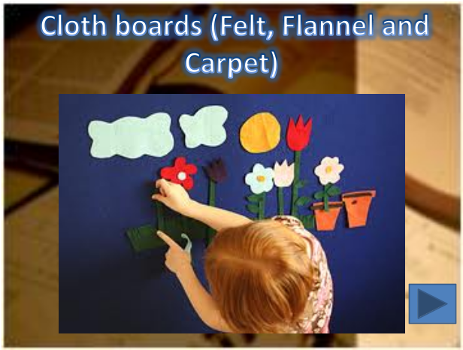
Fig 8 Examples of Cloth boards

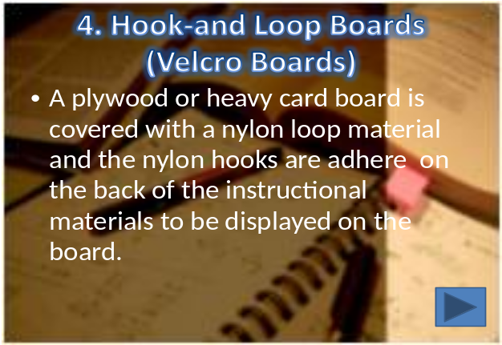
Fig 9 Hook and loop boards
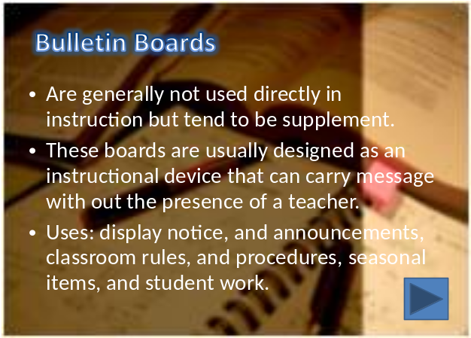
Fig 10a Bulletin boards
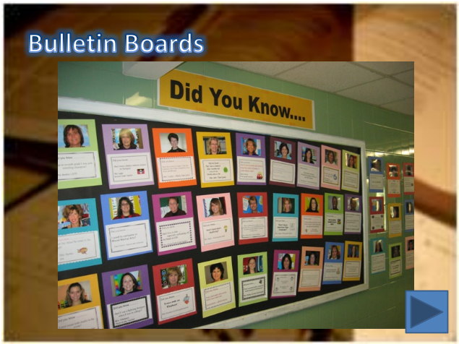
Fig 10b Bulletin boards

3.2.2 Types of Graphic LR
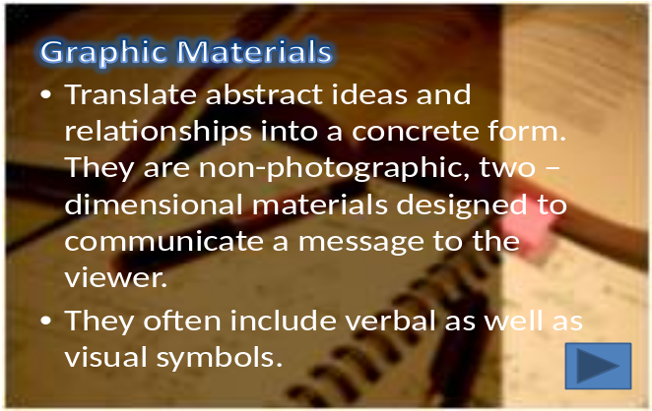
Fig 11 Graphic materials
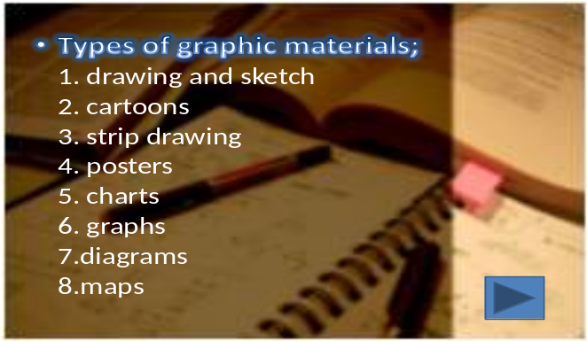
Fig 12 Types of graphic materials

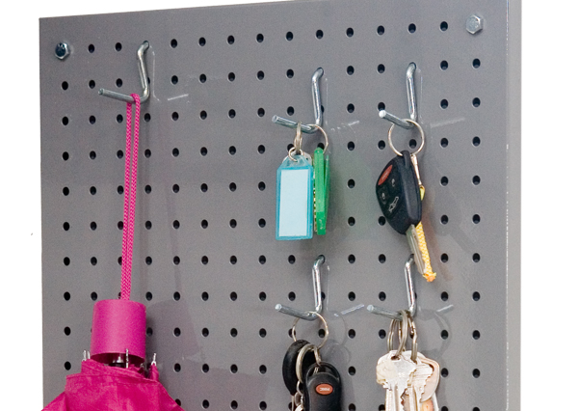

Fig 12 Fixed boards
Activity 3b | Purpose  This activity will help you to think about different ways of presenting information.  Time  This activity will take about 15 minutes.  Write answers to the questions in your workbook.  - Look at the 2D LR below and then make your comments.  - Then draw the organisational chart of your own college.  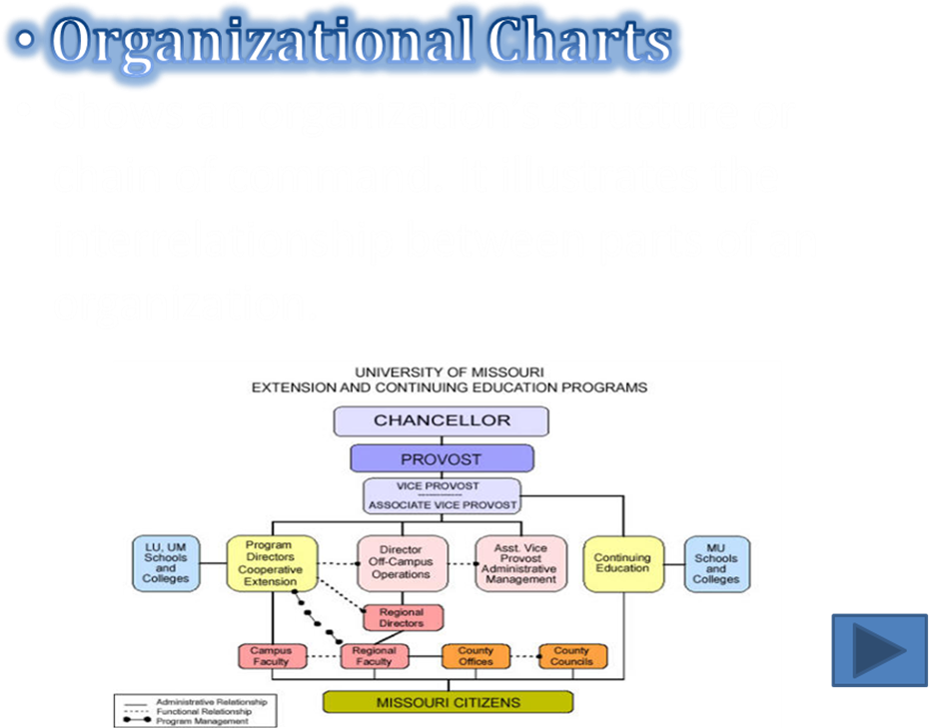  Organisational Charts

Discussion
Discussion

There are many other ways for presenting information graphically, apart from organizational charts.

Let us consider a few more examples.

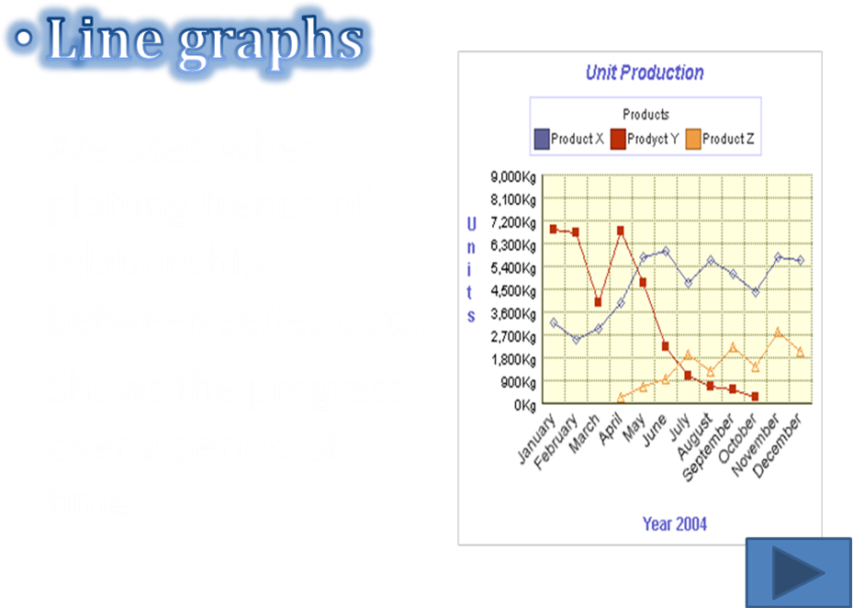
Fig 12 Line Graphs


Fig 13 2-D Drawings Fig 14 3-D drawings

Activity 3c | Purpose  This activity will help you to think about other ways of presenting information.  Time  This activity will take about 2 days.  Write answers to the questions in your workbook.  What is the difference between sketches and drawings?  This is an activity for you to try out with a groups of student-teachers. Guide them through the activity below. Round off with a discussion on what was learned and then write this up for discussion during a contact session with fellow teacher-educators.  - As a teacher-educator list down on a piece of paper the instructional materials used by your students during their teaching practice. (Using Scattergories)  - Look at the instructional materials listed and then identify the 2D instructional materials amongst them  - The educators will describe the characteristics of 2D instructional materials.  - Create two 2D instructional materials in groups of 4 using the PDRS strategy and use the rubric as guide.  - Plan It – The educators will make a plan for their 2D instructional materials (Day 1)  - Do It – The educators will make their instructional materials based on their approved plan. (Day 1)  - Review It – The educators will review their output (2D materials) if follows their plan. (Day 2)  - Share It – The educators will showcase their output in the class demonstrating its proper use. (Day 2)

Discussion
Discussion
Getting teacher students involved in the development and use of learning resources seems like a very good use of our contact time with student-teachers. If we do not create the space during training for such experience, they may never incorporate such activities into their practice.
For more examples use of 2-D learning resources refer to the JSE module, Unit 2.

3.3 Summary
Two-dimensional (2D) learning resources consist only of length and width. They are paper-based, opaque materials that are commonly found in classrooms. These kind of instructional materials do not need any special equipment for its use. They are materials and objects that give support to the learner, aids and facilitate learning. At this time, even in this technologically advanced generation, when you visit classrooms, the most common instructional material you will find are those that are two-dimensional.

Boards
Are vertical surface on which information can be displayed to public view.
Types of Boards
1. Chalk Boards
2. White Boards and Magnetic Boards
3. Cloth Boards (Felt, Flannel and Carpet)
4. Hook-and Loop Boards (Velcro Boards)
5. Pegboards
6. Bulletin Boards

White Boards and Magnetic Boards:
- Also sometimes called multipurpose boards
- These with glossy surface, commonly white in color, where non-permanent markings are made with the use of special felt pens.
- White boards becomes a magnetic boards when it is made with metal base.
- Become popular around the 90’s when there was a growing concerns on the potential health risks of chalk dust.

Advantages:
- Using markers does not generate dust that comes from using the erasing chalk.
- Whiteboards marker is easier to hold and write with compared to chalk and marking a whiteboards takes less time.

Limitations:
- The white backgrounds can cause problems to those with vision impartment.
- Left-handed person may find it difficult to write on these boards because left-handed individuals usually write with their hand curved around the pen therefore causing their hand to drag across the strokes previously made.

Cloth boards:
- This is a piece of plywood or heavy cardboard covered with either felt, flannel or carpet. The fuzzy surface of a felt, flannel, or carpet allows visual material with appropriate backing adhere.

Advantages of 2D LRs:
- Generally suitable for different age groups, class size, and subject matter.
- They are not dependent on electricity.
- They are economical and reusable

Limitations of 2D LRs:
- The white backgrounds can cause problems to those with vision impairment.
- Left-handed learners may find it difficult to write on these boards because left-handed individuals usually write with their hand curved around the pen therefore causing their hand to drag across the strokes previously made.

Bulletin Boards:
- Are generally not used directly in instruction but tend to be supplement.
- These boards are usually designed as an instructional device that can carry message without the presence of a teacher.
- Uses: display notice, and announcements, classroom rules, and procedures, seasonal items, and student work.

Graphic materials:
- Translate abstract ideas and relationships into a concrete form. They are non-photographic, two –dimensional materials designed to communicate a message to the viewer.
- They often include verbal as well as visual symbols.
- Types of graphic materials;
1. drawing and sketch
2. cartoons
3. strip drawing
4. posters
5. charts
6. graphs
7. diagrams
8. maps

Having gone through this much, it is worthy of note here that there is another category of learning resources that have length, breadth and width. They are referred to as 3-D learning resources and that’s the context of discussion in the next unit.

3.4 Self-assessment
Assessment | Tick the boxes to assess whether you have achieved the outcomes for this unit. If you cannot tick the boxes, you should go back and work through the relevant part in the unit again.  I am able to:
  # | Checklist | ☑
  1 | Identify the different types of 2D learning resources | ❑
  2 | Describe the characteristics of 2D learning resources | ❑
  3 | Make 2D learning resources | ❑
  4 | Demonstrate proper use of 2D learning resources | ❑
  5 | Outline the importance of 2D learning resources in the modern world | ❑

3.5 Selected references

Abellera, R.C., Aquino, G.V., & Hidalgo, L.C. (1988). Principles of teaching and educational technology. Diliman, Quezon City: Kalayaan Press.

Brown, James W.et.al. (1977). AV Instruction: Technology, Media, and Methods. McGraw-Hill, Inc.

Corpuz, Brenda et. Al, (2008). Educational Technology 1. Lorimar Publishing, Inc. 776 Aurora Blvd., cor. Boston Street, Cubao, Quezon City, Metro Manila.

Corpuz, B.C. & Lucido, P.I. (2008). Educational technology 1. Q.C.: Lorimar Publishing, Inc.

Dale, E. (1954). Audio-visual methods in teaching. NY: Dryden Press.

4. 3D Learning Resources

3D Learning resources (LRs) are LRs that take up air space. They can also be described as shapes having the dimensions of length, breadth and height or the dimensions of height, depth and width.

Ability to identify, design and construct 3D objects is indispensable for any successful teaching and learning process. 3D learning resources enhance success in teaching: many teachers contemplate how to get their students to learn the various types of 3D shapes found in mathematics, for instance. The best way to do this is by making the students produce them. Students learn best when they are constructors of their own knowledge.
3D models are used in a variety of industries like the movie industries where they are used as characters and objects for animated and real-life motion pictures. The video games and architecture industries use 3D objects as assets for computer and video games and also to demonstrate models of buildings and landscapes. The medical industry also uses detailed models of organs. All these models and other real objects can be effectively utilized in our classrooms.

4.1 Outcomes

Upon completion of this unit, you will be able to:
- Define the concept of 3D learning resources
- Outline the characteristics of 3D LRs.
- Identify that all 3D objects occupy space.
- Use some 3D LRs to enhance teaching and learning.
- Explore the concept of nets and how nets can help us to construct 3D shapes.

4.2 Understanding 3D shapes
Activity 4a | Purpose  This scenario will help you gain a clearer understanding of what a 3D shape is.  Time needed  This activity should take about 10 minutes.  Task  Lawal, a teacher-educator wants to construct a cube, a pyramid, house and a tower. What steps should he follow to do so?
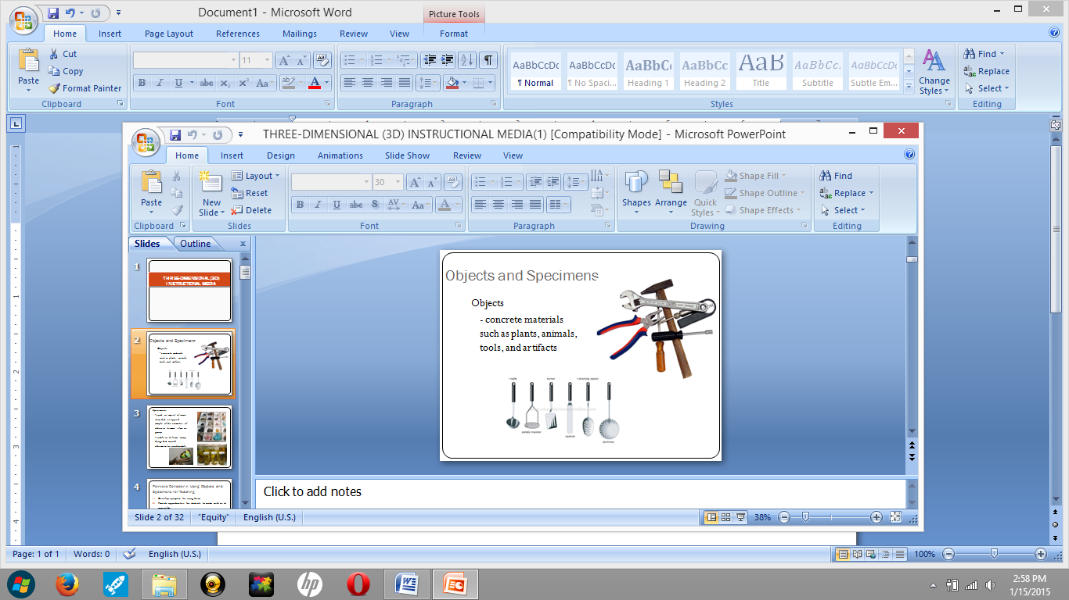
Fig 1 Objects and specimens

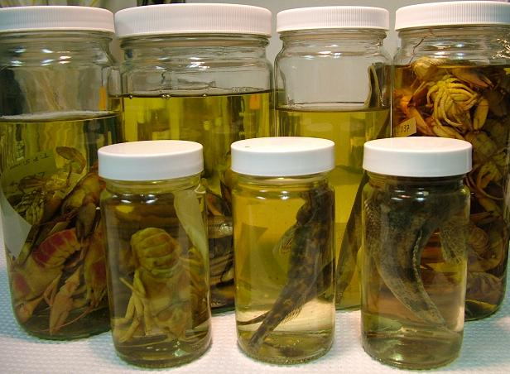
Fig 2a Specimens in bottles 
Fig 2b specimens
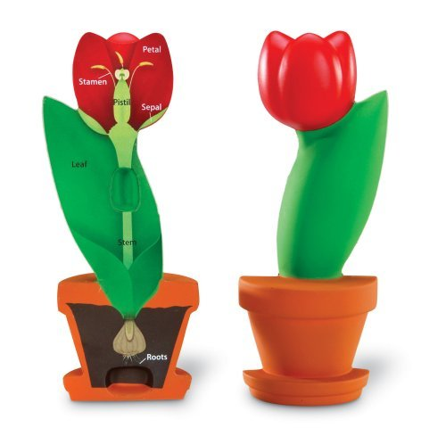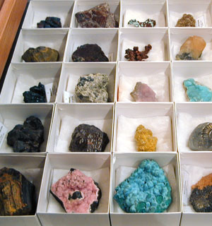
Fig 2c Specimens Fig 2d Specimens

The above figures show examples of 3D resources.

From the above pictures we can see that some 3D shapes consist of solid figures that have faces (sides), edges and vertices (corners) and those are the characteristics of 3D objects.

Refer to JSE module unit 2 to see the classification of 3D shapes.

Activity 4b | Purpose  This activity will help you to think about the resources and processes needed to construct 3D shapes.  Time needed  30 minutes  What to do  Log on to www.greatmathteachingideas.com website.  - Identify the different nets that could be used to make a number of 3D shapes.  - Visualize how the nets could be folded to form solids and make sure that all sides fit together.  - Construct different 3D shapes using the nets.  - Identify the different 2D shapes inside the 3D shapes.  - Compare your constructions with the pictures in the following link:

https://www.google.co.za/search?q=maths+nets+of+3d+shapes&espv=2&biw=1242&bih=606&tbm=isch&tbo=u&source=univ&sa=X&ved=0CBsQsARqFQoTCKHOqP_S3MYCFcq6FAodpW8AlQ

Discussion
Discussion
Getting teacher students involved in the development and use of learning resources seems like a very good use of our contact time with teacher-students. If we do not create the space during training for such experience, they may never incorporate such activities into their practice. Here are some guidelines for constructing 3D shapes.

Steps in constructing some 3D Learning resources
STEP 1
Make balls of clay about 1cm in diameter using plasticine or modeling clay.
STEP 2
Now connect them together using matchsticks or toothpicks.
STEP 3
Construct the various shapes needed by combining different shapes.

3D Sketching with Google Sketch up
This is a 3D modeling tool that is very simple to use.

STEP I
Go to http://sketchup.google.com. Download the executable file and install it.

STEP 2
Draw a house by 1st clicking the "Rectangle" from the toolbar. Now draw the basic shape of your home, on the floor. To be more precise and fast, enter the dimensions in the text box of the lower right corner after your layout rectangle (e.g. "12 m 5 m" for a floor area of 40 square meters). Press Enter to confirm the values. The shape you now have is a rectangle.

STEP 3
Click the "Push / Pull" in the toolbar. Now click on the rectangle to select it. You can stretch up or down. For convenience you can still enter a specific value in the text field. Immediately the form is created and it is 3D modeling you can navigate it as you wish.

STEP 4
Give yourselves a lot of practice using google sketchup.
You can draw cylindrical objects, cubic objects and all sorts of geometric shapes.
To have a full 3D modeling experience you can apply textures to the shapes you have created. This could be done by selecting a surface model and clicking on the bucket of paints (colour) in the toolbar. All colours and textures can be used in sketchup. Better result could however be gotten using a real photo or texture. To do this simply click Choose File > Import. Select one of your pictures on the hard drive and select the radio button "Use as texture”.

4.3 Different 3D shapes
Using cardboard or paper, we can construct the following solid shapes and their corresponding everyday usage.

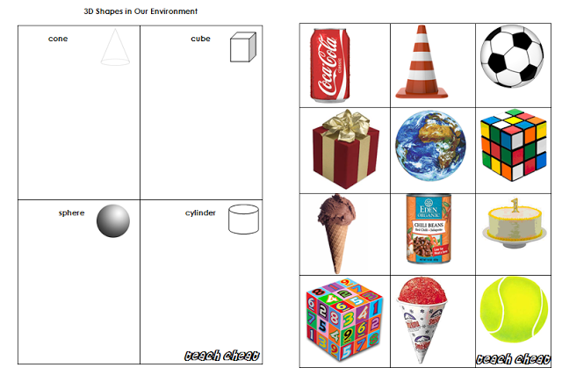
Fig 3 Solid shapes

Do you think 3D shapes are important? Have you ever considered what life would be like without cool drink cans, ice cream packs, the tennis ball and the dice?
Refer to JSE module unit 2 to see the properties of 3-D shapes.

Activity 4c | Purpose  This activity will help you to explore the construction of 3D shapes.  Time needed  30 minutes  What to do  - Go to http://www.shmoop.com/basic-geometry/topics.html .  - Watch the video linked to the topic basic Shapes and Angles and summarise the key ideas.  - Go to http://www.shmoop.com/basic-geometry/volume-pyramids-cones.html  - Watch the video found and discuss how the volumes of pyramids and prisms are derived.

4.4. Summary
A 3D LR is any LR that takes up air and space. It also has any three of length, weight, depth, height and breadth. 3D models are used in a variety of industries like the movie industries where they are used as characters and objects for animated and real-life motion picture. The Video games and architecture industries use 3D objects as assets for computer and video games and also to demonstrate models of buildings and landscapes. The medical industry also uses detailed models of organs. All real objects can be used as learning resources in teaching all subjects.

4.5 Self-assessment

ACTIVITY VI
Give the information as regards to the solids named below:
NAME | PROPERTIES | PICTURE/DIAGRAM
CUBE
CYLINDER
CONE
SPHERE
SQUARE PYRAMID
TRIANGULAR PRISM

ACTIVITY VII

Visit the following websites and download as many free 3D models as you can. See if you can construct some of them.
https://www.3dtotal.com

https://www.turbosquid.com

http://www.greatbuildings.com

http://www.archives3d.net

http://www.3dwarehouse.sketchup.com

Tick the boxes to assess whether you have achieved the outcomes for this unit. If you cannot tick the boxes, you should go back and work through the relevant part in the unit again.
I am able to:
# | Checklist | ☑
1 | Define the concept of 3D LRs | ❑
2 | Outline the characteristics of 3D LRs. | ❑
3 | Identify that all 3D objects occupy space | ❑
4 | Use some 3D LR to enhance teaching and learning | ❑
5 | Explore the concept of nets and how nets can help us to construct 3D shapes. | ❑

4.6 Selected references

- 3D sketching with Google Sketchup. www.en.kioskea.net
- http://www.shmoop.com/basic-geometry/topics.html.

5. Selection of Learning Resources
Selection of Learning Resources (LR) refers to choosing and utilizing the best, most appropriate and most suitable materials that will facilitate learning and teaching when delivering a lesson. And avoiding those materials that will hinder or even prevent learning.

All categories of Educators should ensure that only the most appropriate and teaching materials are included in the curriculum. Selection and use of LR should be appropriate and relevant to the age, sex and the achievement levels of students and to the objectives of the lessons.

5.1 Outcomes

Upon the completion of this unit, you will be able to:
- Enumerate the criteria for selecting learning resources based on vocabulary and sentence structure.
- Identify DVDs/Videos appropriate for teaching and learning.
- Determine appropriate websites that can be used as LR.

Activity 5a | Purpose  This activity will help you understand the general criteria used for selecting LR.  Time  This activity should take about 10 minutes.  Activity 1  1. What advice will you give to a colleague having difficulty selecting learning resources?  2. Why do you think your answers are appropriate?

Discussion
Discussion
Now consider this scenario. Aliyu Umar teaches Biology at a tertiary institution and he has been having a lot of difficulty when it comes to selecting appropriate Learning Resources (LR) for teaching abstract topics like mitosis, meiosis, evolution and many others. He consulted senior colleagues who advised him to consult some textbooks, DVDs and websites, for guidance on selection of learning resources. He came across the following extracts, which will be helpful to you whatever your area of specialisation.

5.2 Principles guiding the selection of Learning Resources
Read through the extract and reflect on the usefulness of these guidelines.

Learning resources should:
- Be activity-based rather than lecture-based

- Draw students into group and co-operative learning as well as provide for individual growth

- Promote hands-on activities and an applied approach to learning

- Encourage students to question, think, react, reflect and decide in ways that develop critical thinking and decision- making skills.

- Offer choice and flexibility, as appropriate to meet needs related to individual aptitudes, abilities, learning styles, multiple intelligences and interests.

- Be supportive of continuous learning by the individual.

- Provide for both formative and summative assessment/evaluation as appropriate.

- Reflect sensitivity to gender and sexual orientation, the perspective of people’s culture and ethnic heritage.

- Recognize the integration of students with special needs (as part of the class).

- Reflect good safety practices in text and visuals (e.g. use of helmets, seatbelts etc.).

- Exclude slang, vernaculars, or expletives that detract from meaning.

Now that you are familiar with the general criteria for selecting LR, it is time for you to get acquainted with the specifics. It will interest you to know that the suitability of vocabulary, sentence structure and graphics are all considered when selecting LR.
Now Read the additional criteria below from Bio Bulletin.

Bio Bulletin
Vol. 2 No. 3 December, 15th 2014

Criteria for selecting LR based on appropriate Vocabulary
- The LR should:
- Explain and define technical terms.
- Not use difficult technical and non-technical words.
- Exclude excessive use of idioms and dialects which increase reading difficulty.

Criteria for selecting LR based on appropriate Sentence Structure
The LR should:
- Not use complex sentence patterns but be alert to attempts to simply by omitting needed connections between ideas.
- Not use unusual or unpredictable sentence patterns and long sentences which increases reading difficulty.
- Consider frequency of pronoun use, especially where referents are ambiguous.

Criteria for selecting Graphics and Illustrations
- Visuals should not be dark, cluttered or have too many competing elements that does support textual content.
- Questions that are asked in captions should be answerable by students.
- Colour, black and white, lines and shapes should be used for visually impaired and learning disabled students.
- Content should be free from factual errors, improper use of statistics, inaccurate graphs and displays, invalid or over simplified models, examples, simulations, errors in spellings or grammar.
- The content should assist the student in achieving the prescribed learning outcomes.
- Treatment of topics should satisfy learning outcomes and is at appropriate level of detail.
- Photographs and realistic drawings are suitable for the maturity, age and or developmental level of students.

Editor: Dr. Aliyu Umar

A publication of the Department of Biology, FCE Katsina.
email: biofatkat@yahoo.com
biofatkat@gmail.com

Activity 5b | Purpose  To familiarise you with role of language in selecting LR  Time needed  This activity should take 15 minutes  - Advance reasons why you think vocabulary and sentence structure should be considered when selecting LR.  - What would be the negative consequences if vocabulary and sentence structure were not considered in selecting LR?

Activity 5c | Purpose  To acquaint you with skills of searching the internet to find criteria for selecting LR  Time needed  This activity should take 30 minutes  Activity 3  At this point you are to consult the following websites and then in your own words supply further criteria for selecting LR.  - http://www.education.vic.gov.au/school/principals/spag/curriculum/Pages/selection.aspx  - http://www.projectmaths.ie/for-teachers/explanation-of-resources/  - www.decd.sa.gov.au/policy/files/links/Choose_use_booklet_FA.pdf  - www.bcerac.ca/resources/whitepapers/docs/ERAC_WB.pdf  - http://www.hwdsb.on.ca/wp-content/uploads/2012/05/Selection-of-Learning-Resources-Directive.pdf

Activity 5d | Purpose  The following activity will enable you to outline and present further criteria for selecting LR during a classroom session  Time  This activity should be carried out within 15 minutes  Activity 3  1. Now read the criteria in the discussion below. Then using Word, tabulate the criteria in your own words.  2. Then present it during the next contact session.

Open the Teaching and learning methods module, for information on the selection, use and integration of teaching methods.

Discussion
Discussion
For any LR to be appropriate, the concepts, visuals and internal structure should be developmentally appropriate and meaningful to a broad range of abilities and achievement levels.
- The number of steps should be logical and well-suited to the intended ability levels.
- There should be multiple levels of instruction to provide for individual differences in students.
- Digital resources that require student response should be as multiple choice, single keystroke, and manipulation of graphics.
- Concepts should be presented one at a time, at a concrete level, for some audiences.
- Links with real-world activities should be incorporated, and provision is made for hands-on experiences.
- The experience of the individual student should form the context for learning.
- The resource should encourage teacher intervention, student contributions, co-operative learning, discovery learning, and collaborative teaching.
- Variety of activities such as concrete, abstract, oral, written, multi-sensory, opportunities for extension, inclusion of explicit aids for retention should be included.

Now read further
- Focusing techniques and cueing devices, such as variations in typeface, boxes, underlining, and spacing should be included.

Activity 5e | Purpose  This activity will allow you to reflect on what you have learnt so far on selection of LR  Time  This activity can be done in 5 minutes  Think about this:  Do you think that all the above criteria are appropriate? If yes, advance reasons for your conclusion.

Discussion
Discussion
All LR should promote critical thinking, research skills, problem solving, group decision making, etc. Students assume increased responsibility for learning, e.g. a tin can, an empty plastic water bottle. Consult the Khan Academy online for a good example of a structured learning environment for individual learning.

- LR should promote development of communication skills through debate, static display, construction, pamphlet writing, small group discussion.
- All LR should develop/promote visual, auditory, and writing skills.
- The resource encourages student creativity through unique interpretations or solutions.
- Digital and Internet resources should be designed to encourage exploration and discovery.
- The progression of the presentation is smooth and logical, with new concepts identified in a clear and consistent manner.

- Material includes links to and/or develops from previously acquired knowledge.
- Technical terms are consistently explained/introduced e.g., in boldface; pause for explanation, accompanied by illustrative examples and student support e.g., glossaries, an index, advance organizers, post-lesson summary.
- Pedagogy is innovative e.g. the resource demonstrates a fresh approach and imagery, layout, presentation, pace, topics, suggested activities, and instructional design to promote student interest in the content:
- Adequate/appropriate assessment/evaluation tools are provided e.g. rubrics, checklists, interviews. Avoid dark or out-of-focus photographs
- Portrayal of the sexes is balanced and sexist, abusive, and/or derogatory reference to gender are avoided and gender or negative types of stereotypes are avoided.
- Children and adults with special needs should be fully respected and integrated.
- Language should be suited to the context, maturity, and intellectual level of the students and avoids profanity, racist, sexist, homophobic and other pejorative terms, slang, jargon, or dialect etc.

5.3 Criteria for selecting DVDs, videos and audios (audio visuals)
Most of us have been watching DVDs, videos and listening to audios for a big part of our lives. However have you ever thought of generating guidelines for production and usage of appropriate DVDs, videos and any audio-visuals in the classroom? Well read the criteria stated below.

- DVDs/videos should include variation in and length of presentation, age-appropriate narration, the provision of meaningful characters and situations, and opportunities for reflection.

- DVD/video programs should be accompanied by a teacher’s guide like synopsis, background information, student activities, questions and glossary of terms.

- Digital LR should customize experiences through interactivity, feedback, and constructive engagement.

- Digital resources should merge a variety of media through the combination of text, video, sound, and graphics.

- A digital learning resource should take into account good instructional design and assessment strategies.

- The DVD/video should extend or builds upon students’ knowledge and productions and should target appropriate levels of the audience.

- DVD/videos covering a number of concepts should have a level of organization that is logical to the student and presented in logical chunks to help the viewer to mentally organize the topic.

- Adequate/appropriate pre- and post-viewing activities should be in the support materials and should extend and consolidate the learning.

- Captions should be clearly readable and shown on the screen for a sufficient length of time.

- Pacing should be neither too slow nor too fast to hold the audience’s attention and stimulate interest in the subject.

- The background required to use the resource should come from common knowledge or previous instruction.

- Instructional requirements should include items such as variable entry/exit points, level of difficulty settings, and variable prompting.

- Students should be able to progress through the material at rates suitable to their abilities and styles.

- The DVD/Video should give feedback in instances where it will promote learning.

- Where appropriate, the program tracks the student, providing prompts or feedback that take into account previous accomplishments or difficulties to correct problems appropriately.

- The resource makes balanced use of graphics, animation, and video with the textual content to enhance learning without overwhelming the presentation.

- Help functions are available easy to use and allow quick response to problems.

- Where appropriate, the resource provides teachers with opportunities to monitor student performance or change the type and frequency of feedback students receive.

Activity 5f | Purpose  This activity will enable you to apply the knowledge you gained so far to evaluate DVDs and videos and determine their appropriateness as LR  Time  The time allowed for this activity is 30 minutes  What to do  Examine the following DVDs and videos and then determine if they meet the criteria for selecting DVDs/Videos as LR  “ How to Select High-Quality Materials by Massachusetts ESE, available at  https://www.youtube.com/watch?v=xEySJlGyvNU  - “The Learning Resource Centre” available on Youtube at https://www.youtube.com/watch?v=hR9J7gpLvOg

5.4 Criteria for selecting LR on websites
Read the following extract about criteria for selecting LR from a website.

Department of Biology
Search

FCE Katsina

Criteria for selecting websites as LR
Three basic aspects of a website should be considered during any evaluation. These are: navigation and usability, authorship and validity of content.
- The website should clearly indicate who is responsible for the contents of the page, author qualifications, contact information, latest versions/updates and copyright information.
- Sources of factual information should be clearly listed for verification purposes.
- Students should be able to progress through the material at rates suitable to their physical and intellectual maturity, abilities and styles.
- Links to other websites should be provided to support and enhance the information provided.
- The website should provide information that is useful to the student’s specific purpose and bring some added value to learning that is not present in other formats.
- The content and concepts of the website should be organized logically into segments appropriate to the student’s abilities.

www.bioeducation.org
email: biofatkat@yahoo.com
biofatkat@gmail.com

Department of Biology, FCE Katsian
© Department of Biology, FCE Katsian, PMB 2041, Katsina, Katsina State, Nigeria

Activity 5g | Purpose  This activity will allow you to reflect back on what you have learned so far and also enable you to guide others on how to select LR  Time needed  This activity can be done in 20 minutes  Write answers in your workbook  - Having learned this much, what advice will you give to Aliyu Umar as a guide for selecting LR?  - In your opinion does it matter whether the criteria for selecting LR are enforced or not?  - Did you adhere to the criteria for selecting LR before reading this unit? If no, would you continue ignoring the criteria for selecting LR in your subsequent lessons?

Discussion
Discussion
For any LR to be considered appropriate for learning and teaching it must be consistent with the criteria for selecting LR based on appropriate vocabulary, sentence structure, graphics and illustrations, DVDs and audio visuals enumerated in the previous sections.

5.5 Summary
Learning resources should:
  - be activity-based rather than lecture-based
  - draw students into group and co-operative learning, as well as provide for individual growth
  - promote hands-on activities and an applied approach to learning
  - encourage students to question, think, react, reflect, and decide in ways that develop critical-thinking and decision-making skills
  - offer choice and flexibility, as appropriate, to meet needs related to individual aptitudes, abilities, learning styles, multiple intelligences, and interests.
  - Explain, and define technical terms.
  - not use difficult technical and non-technical words.
  - not use complex sentence patterns but be alert to attempts to simplify by omitting needed connections between ideas.
  - Colour, black and white, lines and shapes are used for visually impaired and learning disabled students.
  - There are multiple levels of instruction to provide for individual differences in students.
  - Photographs and realistic drawings, are suitable for the maturity, age, and/or developmental level of students.
  - In digital resources that require student response should be as multiple choice, single keystroke, and manipulation of graphics.
- The resource should encourage student creativity through unique interpretations or solutions.
- The resource should allow/encourage students to work independently through exploration rather than be locked into a linear instructional sequence
- Definitions, explanations, illustrations, and examples are available where necessary and are relevant to the point under discussion.
  - Material includes links to and/or develops from previously acquired knowledge.
- Appropriate support materials are provided e.g. sufficient material for a variety of activities including pre-instruction and follow-up, description of the instructional activities
- DVD/video programs should be accompanied by a teacher’s guide like synopsis, background information, student activities, questions and glossary of terms
- Digital LR should customize experiences through interactivity, feedback, and constructive engagement.
- Narration messages should be audible over background sound.
- The narration should carry an appropriate tone and clarity.
- The voice should carry an authoritative tone without being patronizing.
- Sound tracks should avoid distractions, and sound should enhance affective goals and effectiveness of the message.
- Sources of factual information should be clearly listed for verification purposes.
- Students should be able to progress through the material at rates suitable to their physical and intellectual maturity, abilities, and styles.
- Links should be provided to other sites to support or enhance the information presented.
- The site should provide information that is useful to the student’s specific purpose and/or bring some added value to learning that is not present in other formats.
 | How well do these criteria reflect your own beliefs and practice? Do they speak to your personal believes for teaching and learning?
  Reflection

5.6 Self-assessment
Activity
- Create a mind map summary of each of the different categories of the criteria for selecting LR you have learned thus far.
- Produce a single mind map summary for the whole criteria for selecting LR you have learned so far.

Let us try to summarise what we learned in this unit using the following table
 | Selection Criteria
Vocabulary | 1.  2.  3.  4.  5.
Sentence structure | 1.  2.  3.  4.  5.
Graphics/illustrations | 1.  2.  3.  4.  5.
DVDs/Videos | 1.  2.  3.  4.  5.
Websites | 1.  2.  3.  4.  5.

Activity
Now let us try to bring things together
What are some of the criteria for selecting LR that caught your attention more strongly?
Choose at least one criterion from each of the categories discussed thus far that interest you the most and write them in the box below.

Then for each selected criteria, i) discuss why you think it is necessary for learning and teaching and ii) how can it facilitate teaching and learning? You can use the following format:
Criteria………………………………………………………………………………………………………………………………………………………………………………………………………………………………………………………….
- Why do you think it is necessary for learning and teaching?
……………………………………………………………………………………………………………………………………………………………………………………
- How can it facilitate learning and teaching?
……………………………………………………………………………………………………………………………………………………………………………………

Tick the boxes to assess whether you have achieved the outcomes for this unit and for the module as a whole. If you cannot tick the boxes, you should go back and work through the relevant part in the unit again.
I am able to:
# | Checklist | ☑
1 | Enumerate the criteria for selecting learning resources based on vocabulary and sentence structure. | ❑
2 | Identify DVDs/Videos appropriate for teaching and learning | ❑
3 | Determine appropriate websites that can be used as LRs. | ❑

5.7 Selected references
Blue Valley U.S.D. #229 Board Policy, Selection of Learning Resources 4600a
Delta School District (37 May, 2013). Administrative Procedures Manual
School District 50: Haida Gwaii/Queen Charlotte (1999). Locally Recommended Learning Resources. Policy No. 3120

Revelstoke Board of Education, Canada (2010). Policy Manual

Karampiperis, P., & Sampson, D. (2005). Adaptive Learning Resources Sequencing In Educational Hypermedia Systems. Educational Technology & Society, 8 (4), 128-147.

Prince Edward Island Department of Education (2008). Evaluation and Selection of Learning Resources: A Guide. Charlottetown, Prince Edward Island, Canada, C1a 7n8. http://www.gov.pe.ca/educ

www.decd.sa.gov.au/policy/files/links/Choose_use_booklet_FA.pdf
www2.gov.bc.ca/gov/topic.page?id...

www.learningresources.com/category/teacher+resources.do

www.hwdsb.on.ca/wp-content/.../Selection-of-Learning-Resources.pdf

www.vsb.bc.ca › About VSB › Policy Manual

www.projectmaths.ie/learningResources/guideline.asp

www.decd.sa.gov.au/policy/files/links/Choose_use_booklet_FA.pdf

Glossary
2 D learning resource: an object with 2 dimensions of length and breadth.
3-D learning resource: An object with 3 dimensions of length, breadth and height or depth or weight
Active learning: an experience acquired and which is functional
Application of Learning Resources: putting into practice the theoretical knowledge
Classification of Learning Resources: grouping based on common characteristics
Collaborative teaching – learning through peer review
Colourfulness – keep changing activities to attract or sustain learning
Common media – media found everywhere
Community resources – are learning resources that can be found within a community
Constructivism – learning by doing, and talking and thinking about what is done e.g. construct
Contextualize school learning – connect classroom learning to real life experience
Co-operative learning – learning in a group
Creativity – ability to initiate something new
Cross-field outcomes – outcomes that cut across subjects
Curriculum – the total learning experience
Discovery learning – a process of learning through asking questions and performing experiments or researching to find answers rather than being told answers
Educational resources – learning resources
Effective teaching – functional teaching
Entry points – ready to starting learning
Exit points – achievement of outcomes
Generic Skills – skills applicable to all subjects
Hands-on experience – an experience that involve active participation
Inquisitiveness – a curious interest to learn
Instructional materials: are learning materials used in teaching and learning process to enhance effective teaching and learning.
Integrate Learning Resources – appropriate introduction of learning resources into a lesson
Learning area skills: specific attributes of learning in a particular field e.g. learning maths as opposed to learning a language
Learning resources: materials used to explain, describe, illustrate or acquire knowledge.
Learning strategies: tactics, process or means by which knowledge or experiences are acquired.
Life-long learning: learning that continues throughout life e.g. at school, at college, in the workplace, at home …
Modern classrooms: are smart classrooms with all gadgets and which can be manipulated for grouping and other activities
Open Educational Resources (OER): are educational resources that are licensed for use, re-use and distribution with minimal or no restrictions and at no cost
Passive learners: are inactive learners
Pre-viewing activities – Activities to be completed prior to watching a video or animation etc.
Post-viewing activities – Activities to completed after watching a video or animation etc.
Professional competency: is sustained expertise in a field of learning e.g. teaching.
Professionally qualified person: a person who possessed or acquired competency skills
Resource-based: learning supported by resources
Resourcefulness: multiple usage of learning resources by a teacher
Scaffold – moving learners through progressively stronger and independent understanding
Scientific concepts – are theories, principles and laws guiding science
Scientific processes – observation, hypothesis, experiment, findings, inference, and conclusion
Selection of Learning Resources – guided choice of educational resources
Specific skills: specific attributes of a subject matter
Student-teacher: A learner who is expected to teach after his learning process.
Specimens – are materials kept specifically for learning e.g. preserved fish, birds in a laboratory.
Teacher-educator: is a facilitator/instructor/teacher for teachers.
Abbreviations
CD – Compact Disk
DVD – Digital Versatile Disk
L R – Learning Resources
C P D – Continuing Professional Development

